**Project Use Case Analysis**

*Date : 04-20-2022*

*Project Name -*

***Restaurant Management System***

CS 6359: Object-Oriented Analysis and Design

Instructor: R. Z. Wenkstern

TA: Sultan Alsarra

*Rohit Rajkumar Kriplani*

*Sirisha Satish*

*Sindhu Chandana Gadipudi*

*Greeshma Naga Lakshmi Palisetty*

***Table of Contents***

**I. DOMAIN MODEL 3**

Revision History 3

**II. USE CASE MODELS 5**

Revision History 5

1. Use Case Diagrams 6

*1.1.* *UCD Level 0 6*

*1.2.* *UCD Level 1 6*

*1.3.* *UCD Prioritization (at level 0) 6*

2. Use Case Descriptions 6

*2.1.* *UC 1 6*

*2.2.1* *UC1 Description 6*

2.2.2 UC 1 «Includes» 6

2.2.3 UC 1 «Extends» 6

2.2.4 UC 1 Non-Functional Requirements 6

*2.2.* *UC 2 6*

*2.2.1* *UC 2 Description 6*

2.2.2 UC 2 «Includes» 6

2.2.3 UC 2 «Extends» 6

2.2.4 UC 2 Non-Functional Requirements 6

*2.3.* *UC 3 7*

*2.3.1 UC 3 Description 7*

2.3.2 UC 3 «Includes» 7

2.3.3 UC 3 «Extends» 7

2.3.4 UC 3 Non-Functional Requirements 7

Etc. 7

**III. SYSTEM SEQUENCE DIAGRAMS 8**

Revision History 8

1. UC1 System Sequence Diagram 9

# **I. Domain Model**

Version 1.0

Date : 04-13-2022

## ***Revision History***

| **Version - description** | **Date** | **Description** | **Author** |
| --- | --- | --- | --- |
| vs 1.0 - Inception draft | … | First draft. To be refined primarily during elaboration. | … |
| Elaboration 1 draft 1 | … |  | … |
| Elaboration 1 draft 2 | … |  | … |
|  |  |  |  |

*Domain Model v1.0*

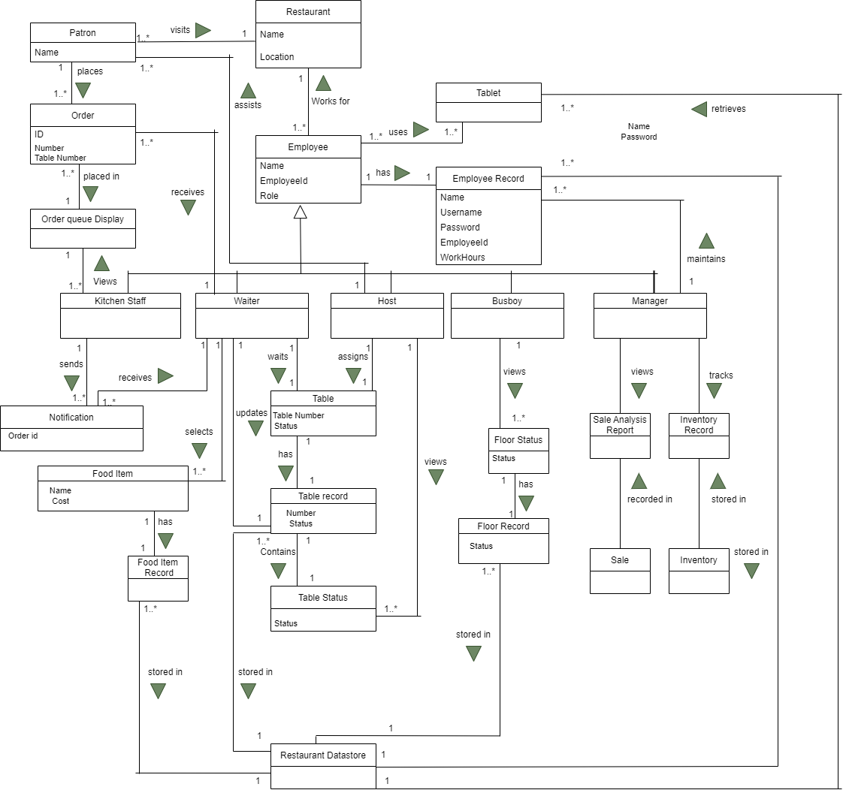

*Domain Model v1.1*

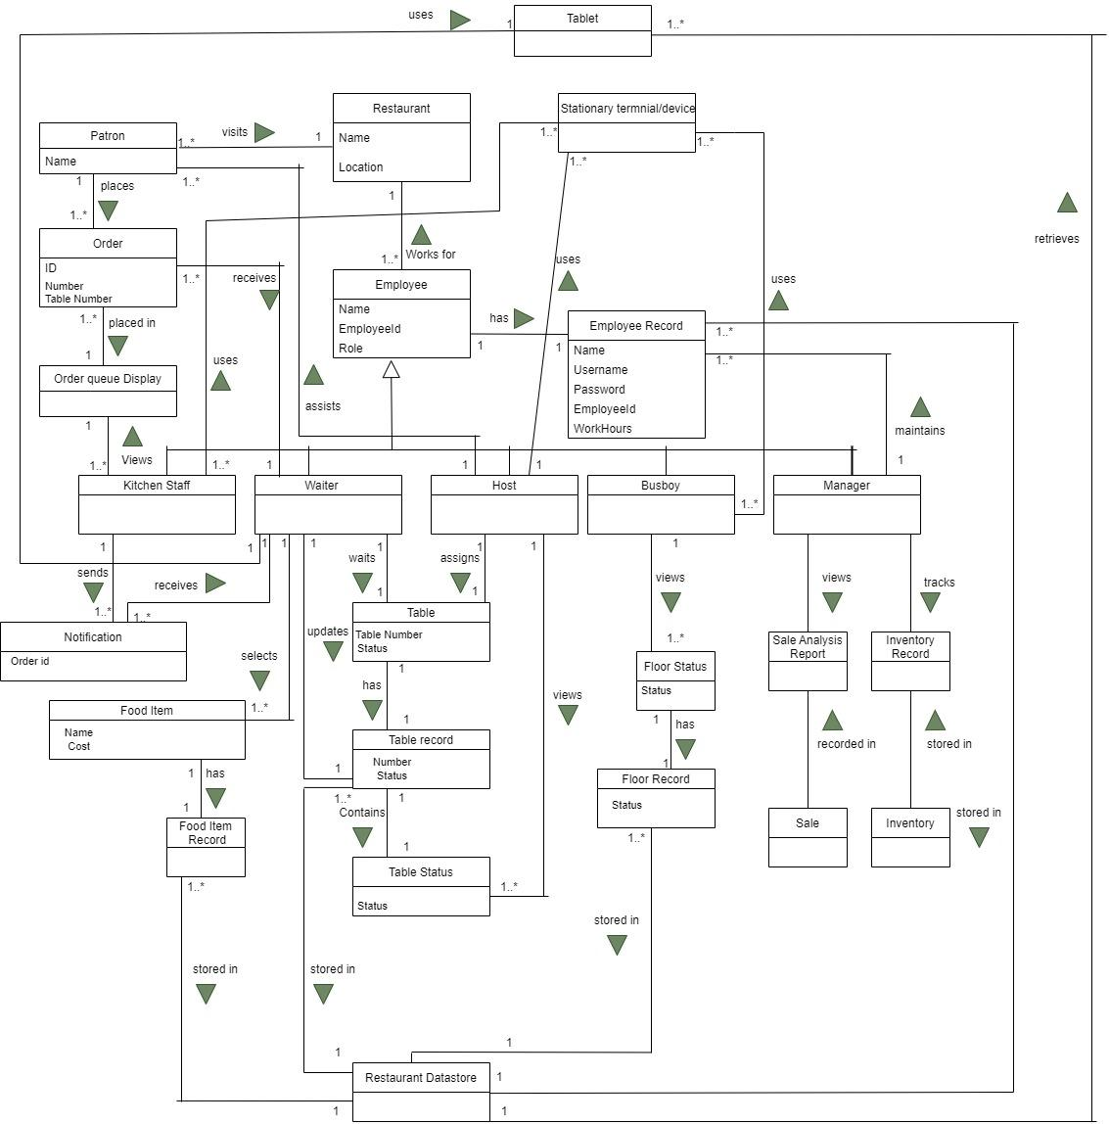

%3CmxGraphModel%3E%3Croot%3E%3CmxCell%20id%3D%220%22%2F%3E%3CmxCell%20id%3D%221%22%20parent%3D%220%22%2F%3E%3CmxCell%20id%3D%222%22%20value%3D%22Restaurant%22%20style%3D%22swimlane%3BfontStyle%3D0%3BchildLayout%3DstackLayout%3Bhorizontal%3D1%3BstartSize%3D30%3BhorizontalStack%3D0%3BresizeParent%3D1%3BresizeParentMax%3D0%3BresizeLast%3D0%3Bcollapsible%3D1%3BmarginBottom%3D0%3B%22%20vertex%3D%221%22%20parent%3D%221%22%3E%3CmxGeometry%20x%3D%223860%22%20y%3D%22470%22%20width%3D%22140%22%20height%3D%2290%22%20as%3D%22geometry%22%2F%3E%3C%2FmxCell%3E%3CmxCell%20id%3D%223%22%20value%3D%22Name%C2%A0%C2%A0%C2%A0%C2%A0%C2%A0%C2%A0%C2%A0%C2%A0%22%20style%3D%22text%3BstrokeColor%3Dnone%3BfillColor%3Dnone%3Balign%3Dleft%3BverticalAlign%3Dmiddle%3BspacingLeft%3D4%3BspacingRight%3D4%3Boverflow%3Dhidden%3Bpoints%3D%5B%5B0%2C0.5%5D%2C%5B1%2C0.5%5D%5D%3BportConstraint%3Deastwest%3Brotatable%3D0%3B%22%20vertex%3D%221%22%20parent%3D%222%22%3E%3CmxGeometry%20y%3D%2230%22%20width%3D%22140%22%20height%3D%2230%22%20as%3D%22geometry%22%2F%3E%3C%2FmxCell%3E%3CmxCell%20id%3D%224%22%20value%3D%22Location%22%20style%3D%22text%3BstrokeColor%3Dnone%3BfillColor%3Dnone%3Balign%3Dleft%3BverticalAlign%3Dmiddle%3BspacingLeft%3D4%3BspacingRight%3D4%3Boverflow%3Dhidden%3Bpoints%3D%5B%5B0%2C0.5%5D%2C%5B1%2C0.5%5D%5D%3BportConstraint%3Deastwest%3Brotatable%3D0%3B%22%20vertex%3D%221%22%20parent%3D%222%22%3E%3CmxGeometry%20y%3D%2260%22%20width%3D%22140%22%20height%3D%2230%22%20as%3D%22geometry%22%2F%3E%3C%2FmxCell%3E%3CmxCell%20id%3D%225%22%20value%3D%22Employee%22%20style%3D%22swimlane%3BfontStyle%3D0%3BchildLayout%3DstackLayout%3Bhorizontal%3D1%3BstartSize%3D30%3BhorizontalStack%3D0%3BresizeParent%3D1%3BresizeParentMax%3D0%3BresizeLast%3D0%3Bcollapsible%3D1%3BmarginBottom%3D0%3B%22%20vertex%3D%221%22%20parent%3D%221%22%3E%3CmxGeometry%20x%3D%223860%22%20y%3D%22650%22%20width%3D%22140%22%20height%3D%2290%22%20as%3D%22geometry%22%2F%3E%3C%2FmxCell%3E%3CmxCell%20id%3D%226%22%20value%3D%22Name%C2%A0%C2%A0%C2%A0%C2%A0%22%20style%3D%22text%3BstrokeColor%3Dnone%3BfillColor%3Dnone%3Balign%3Dleft%3BverticalAlign%3Dmiddle%3BspacingLeft%3D4%3BspacingRight%3D4%3Boverflow%3Dhidden%3Bpoints%3D%5B%5B0%2C0.5%5D%2C%5B1%2C0.5%5D%5D%3BportConstraint%3Deastwest%3Brotatable%3D0%3B%22%20vertex%3D%221%22%20parent%3D%225%22%3E%3CmxGeometry%20y%3D%2230%22%20width%3D%22140%22%20height%3D%2220%22%20as%3D%22geometry%22%2F%3E%3C%2FmxCell%3E%3CmxCell%20id%3D%227%22%20value%3D%22EmployeeId%22%20style%3D%22text%3BstrokeColor%3Dnone%3BfillColor%3Dnone%3Balign%3Dleft%3BverticalAlign%3Dmiddle%3BspacingLeft%3D4%3BspacingRight%3D4%3Boverflow%3Dhidden%3Bpoints%3D%5B%5B0%2C0.5%5D%2C%5B1%2C0.5%5D%5D%3BportConstraint%3Deastwest%3Brotatable%3D0%3B%22%20vertex%3D%221%22%20parent%3D%225%22%3E%3CmxGeometry%20y%3D%2250%22%20width%3D%22140%22%20height%3D%2220%22%20as%3D%22geometry%22%2F%3E%3C%2FmxCell%3E%3CmxCell%20id%3D%228%22%20value%3D%22Role%22%20style%3D%22text%3BstrokeColor%3Dnone%3BfillColor%3Dnone%3Balign%3Dleft%3BverticalAlign%3Dmiddle%3BspacingLeft%3D4%3BspacingRight%3D4%3Boverflow%3Dhidden%3Bpoints%3D%5B%5B0%2C0.5%5D%2C%5B1%2C0.5%5D%5D%3BportConstraint%3Deastwest%3Brotatable%3D0%3B%22%20vertex%3D%221%22%20parent%3D%225%22%3E%3CmxGeometry%20y%3D%2270%22%20width%3D%22140%22%20height%3D%2220%22%20as%3D%22geometry%22%2F%3E%3C%2FmxCell%3E%3CmxCell%20id%3D%229%22%20value%3D%22Kitchen%20Staff%22%20style%3D%22swimlane%3BfontStyle%3D0%3BchildLayout%3DstackLayout%3Bhorizontal%3D1%3BstartSize%3D20%3BhorizontalStack%3D0%3BresizeParent%3D1%3BresizeParentMax%3D0%3BresizeLast%3D0%3Bcollapsible%3D1%3BmarginBottom%3D0%3B%22%20vertex%3D%221%22%20parent%3D%221%22%3E%3CmxGeometry%20x%3D%223600%22%20y%3D%22860%22%20width%3D%22160%22%20height%3D%2260%22%20as%3D%22geometry%22%2F%3E%3C%2FmxCell%3E%3CmxCell%20id%3D%2210%22%20value%3D%22Waiter%C2%A0%C2%A0%C2%A0%C2%A0%22%20style%3D%22swimlane%3BfontStyle%3D0%3BchildLayout%3DstackLayout%3Bhorizontal%3D1%3BstartSize%3D20%3BhorizontalStack%3D0%3BresizeParent%3D1%3BresizeParentMax%3D0%3BresizeLast%3D0%3Bcollapsible%3D1%3BmarginBottom%3D0%3B%22%20vertex%3D%221%22%20parent%3D%221%22%3E%3CmxGeometry%20x%3D%223780%22%20y%3D%22860%22%20width%3D%22150%22%20height%3D%2260%22%20as%3D%22geometry%22%2F%3E%3C%2FmxCell%3E%3CmxCell%20id%3D%2211%22%20value%3D%22Host%22%20style%3D%22swimlane%3BfontStyle%3D0%3BchildLayout%3DstackLayout%3Bhorizontal%3D1%3BstartSize%3D20%3BhorizontalStack%3D0%3BresizeParent%3D1%3BresizeParentMax%3D0%3BresizeLast%3D0%3Bcollapsible%3D1%3BmarginBottom%3D0%3B%22%20vertex%3D%221%22%20parent%3D%221%22%3E%3CmxGeometry%20x%3D%223960%22%20y%3D%22860%22%20width%3D%22150%22%20height%3D%2260%22%20as%3D%22geometry%22%2F%3E%3C%2FmxCell%3E%3CmxCell%20id%3D%2212%22%20value%3D%22Busboy%22%20style%3D%22swimlane%3BfontStyle%3D0%3BchildLayout%3DstackLayout%3Bhorizontal%3D1%3BstartSize%3D20%3BhorizontalStack%3D0%3BresizeParent%3D1%3BresizeParentMax%3D0%3BresizeLast%3D0%3Bcollapsible%3D1%3BmarginBottom%3D0%3B%22%20vertex%3D%221%22%20parent%3D%221%22%3E%3CmxGeometry%20x%3D%224120%22%20y%3D%22860%22%20width%3D%22150%22%20height%3D%2260%22%20as%3D%22geometry%22%2F%3E%3C%2FmxCell%3E%3CmxCell%20id%3D%2213%22%20value%3D%22Manager%22%20style%3D%22swimlane%3BfontStyle%3D0%3BchildLayout%3DstackLayout%3Bhorizontal%3D1%3BstartSize%3D20%3BhorizontalStack%3D0%3BresizeParent%3D1%3BresizeParentMax%3D0%3BresizeLast%3D0%3Bcollapsible%3D1%3BmarginBottom%3D0%3B%22%20vertex%3D%221%22%20parent%3D%221%22%3E%3CmxGeometry%20x%3D%224310%22%20y%3D%22860%22%20width%3D%22150%22%20height%3D%2260%22%20as%3D%22geometry%22%2F%3E%3C%2FmxCell%3E%3CmxCell%20id%3D%2214%22%20value%3D%22%22%20style%3D%22line%3BstrokeWidth%3D1%3BfillColor%3Dnone%3Balign%3Dleft%3BverticalAlign%3Dmiddle%3BspacingTop%3D-1%3BspacingLeft%3D3%3BspacingRight%3D3%3Brotatable%3D0%3BlabelPosition%3Dright%3Bpoints%3D%5B%5D%3BportConstraint%3Deastwest%3B%22%20vertex%3D%221%22%20parent%3D%221%22%3E%3CmxGeometry%20x%3D%223690%22%20y%3D%22830%22%20width%3D%22705%22%20height%3D%228%22%20as%3D%22geometry%22%2F%3E%3C%2FmxCell%3E%3CmxCell%20id%3D%2215%22%20value%3D%22%22%20style%3D%22line%3BstrokeWidth%3D1%3Bdirection%3Dsouth%3Bhtml%3D1%3B%22%20vertex%3D%221%22%20parent%3D%221%22%3E%3CmxGeometry%20x%3D%223830%22%20y%3D%22830%22%20width%3D%2210%22%20height%3D%2230%22%20as%3D%22geometry%22%2F%3E%3C%2FmxCell%3E%3CmxCell%20id%3D%2216%22%20value%3D%22%22%20style%3D%22line%3BstrokeWidth%3D1%3Bdirection%3Dsouth%3Bhtml%3D1%3B%22%20vertex%3D%221%22%20parent%3D%221%22%3E%3CmxGeometry%20x%3D%224035%22%20y%3D%22830%22%20width%3D%2210%22%20height%3D%2230%22%20as%3D%22geometry%22%2F%3E%3C%2FmxCell%3E%3CmxCell%20id%3D%2217%22%20value%3D%22%22%20style%3D%22line%3BstrokeWidth%3D1%3Bdirection%3Dsouth%3Bhtml%3D1%3B%22%20vertex%3D%221%22%20parent%3D%221%22%3E%3CmxGeometry%20x%3D%224195%22%20y%3D%22830%22%20width%3D%2210%22%20height%3D%2230%22%20as%3D%22geometry%22%2F%3E%3C%2FmxCell%3E%3CmxCell%20id%3D%2218%22%20value%3D%22%22%20style%3D%22line%3BstrokeWidth%3D2%3Bdirection%3Dsouth%3Bhtml%3D1%3B%22%20vertex%3D%221%22%20parent%3D%221%22%3E%3CmxGeometry%20x%3D%224385%22%20y%3D%22830%22%20width%3D%2210%22%20height%3D%2230%22%20as%3D%22geometry%22%2F%3E%3C%2FmxCell%3E%3CmxCell%20id%3D%2219%22%20value%3D%22Patron%22%20style%3D%22swimlane%3BfontStyle%3D0%3BchildLayout%3DstackLayout%3Bhorizontal%3D1%3BstartSize%3D26%3BfillColor%3Dnone%3BhorizontalStack%3D0%3BresizeParent%3D1%3BresizeParentMax%3D0%3BresizeLast%3D0%3Bcollapsible%3D1%3BmarginBottom%3D0%3B%22%20vertex%3D%221%22%20parent%3D%221%22%3E%3CmxGeometry%20x%3D%223560%22%20y%3D%22500%22%20width%3D%22140%22%20height%3D%2252%22%20as%3D%22geometry%22%2F%3E%3C%2FmxCell%3E%3CmxCell%20id%3D%2220%22%20value%3D%22Name%22%20style%3D%22text%3BstrokeColor%3Dnone%3BfillColor%3Dnone%3Balign%3Dleft%3BverticalAlign%3Dtop%3BspacingLeft%3D4%3BspacingRight%3D4%3Boverflow%3Dhidden%3Brotatable%3D0%3Bpoints%3D%5B%5B0%2C0.5%5D%2C%5B1%2C0.5%5D%5D%3BportConstraint%3Deastwest%3B%22%20vertex%3D%221%22%20parent%3D%2219%22%3E%3CmxGeometry%20y%3D%2226%22%20width%3D%22140%22%20height%3D%2226%22%20as%3D%22geometry%22%2F%3E%3C%2FmxCell%3E%3CmxCell%20id%3D%2221%22%20value%3D%22Tablet%22%20style%3D%22swimlane%3BfontStyle%3D0%3BchildLayout%3DstackLayout%3Bhorizontal%3D1%3BstartSize%3D26%3BfillColor%3Dnone%3BhorizontalStack%3D0%3BresizeParent%3D1%3BresizeParentMax%3D0%3BresizeLast%3D0%3Bcollapsible%3D1%3BmarginBottom%3D0%3B%22%20vertex%3D%221%22%20parent%3D%221%22%3E%3CmxGeometry%20x%3D%224045%22%20y%3D%22380%22%20width%3D%22140%22%20height%3D%2252%22%20as%3D%22geometry%22%2F%3E%3C%2FmxCell%3E%3CmxCell%20id%3D%2222%22%20value%3D%22%22%20style%3D%22line%3BstrokeWidth%3D1%3Bdirection%3Dsouth%3Bhtml%3D1%3B%22%20vertex%3D%221%22%20parent%3D%221%22%3E%3CmxGeometry%20x%3D%223925%22%20y%3D%22560%22%20width%3D%2210%22%20height%3D%2290%22%20as%3D%22geometry%22%2F%3E%3C%2FmxCell%3E%3CmxCell%20id%3D%2223%22%20value%3D%22Works%20for%22%20style%3D%22text%3Bhtml%3D1%3BstrokeColor%3Dnone%3BfillColor%3Dnone%3Balign%3Dcenter%3BverticalAlign%3Dmiddle%3BwhiteSpace%3Dwrap%3Brounded%3D0%3B%22%20vertex%3D%221%22%20parent%3D%221%22%3E%3CmxGeometry%20x%3D%223920%22%20y%3D%22620%22%20width%3D%2280%22%20height%3D%2230%22%20as%3D%22geometry%22%2F%3E%3C%2FmxCell%3E%3CmxCell%20id%3D%2224%22%20value%3D%22%22%20style%3D%22triangle%3BwhiteSpace%3Dwrap%3Bhtml%3D1%3BfillColor%3D%236d8764%3BfontColor%3D%23ffffff%3BstrokeColor%3D%233A5431%3Bdirection%3Dnorth%3B%22%20vertex%3D%221%22%20parent%3D%221%22%3E%3CmxGeometry%20x%3D%223940%22%20y%3D%22604%22%20width%3D%2220%22%20height%3D%2220%22%20as%3D%22geometry%22%2F%3E%3C%2FmxCell%3E%3CmxCell%20id%3D%2225%22%20value%3D%22%22%20style%3D%22endArrow%3Dnone%3Bhtml%3D1%3Brounded%3D0%3BstartArrow%3Dnone%3B%22%20edge%3D%221%22%20parent%3D%221%22%3E%3CmxGeometry%20width%3D%2250%22%20height%3D%2250%22%20relative%3D%221%22%20as%3D%22geometry%22%3E%3CmxPoint%20x%3D%224130%22%20y%3D%22660%22%20as%3D%22sourcePoint%22%2F%3E%3CmxPoint%20x%3D%224130%22%20y%3D%22660%22%20as%3D%22targetPoint%22%2F%3E%3C%2FmxGeometry%3E%3C%2FmxCell%3E%3CmxCell%20id%3D%2226%22%20value%3D%22%22%20style%3D%22endArrow%3Dnone%3Bhtml%3D1%3Brounded%3D0%3B%22%20edge%3D%221%22%20parent%3D%221%22%3E%3CmxGeometry%20width%3D%2250%22%20height%3D%2250%22%20relative%3D%221%22%20as%3D%22geometry%22%3E%3CmxPoint%20x%3D%224000%22%20y%3D%22715.5%22%20as%3D%22sourcePoint%22%2F%3E%3CmxPoint%20x%3D%224100%22%20y%3D%22716%22%20as%3D%22targetPoint%22%2F%3E%3C%2FmxGeometry%3E%3C%2FmxCell%3E%3CmxCell%20id%3D%2227%22%20value%3D%22has%22%20style%3D%22text%3Bhtml%3D1%3BstrokeColor%3Dnone%3BfillColor%3Dnone%3Balign%3Dcenter%3BverticalAlign%3Dmiddle%3BwhiteSpace%3Dwrap%3Brounded%3D0%3B%22%20vertex%3D%221%22%20parent%3D%221%22%3E%3CmxGeometry%20x%3D%224000%22%20y%3D%22690%22%20width%3D%2260%22%20height%3D%2220%22%20as%3D%22geometry%22%2F%3E%3C%2FmxCell%3E%3CmxCell%20id%3D%2228%22%20value%3D%22%22%20style%3D%22triangle%3BwhiteSpace%3Dwrap%3Bhtml%3D1%3BfillColor%3D%236d8764%3BfontColor%3D%23ffffff%3BstrokeColor%3D%233A5431%3Bdirection%3Deast%3B%22%20vertex%3D%221%22%20parent%3D%221%22%3E%3CmxGeometry%20x%3D%224045%22%20y%3D%22690%22%20width%3D%2220%22%20height%3D%2220%22%20as%3D%22geometry%22%2F%3E%3C%2FmxCell%3E%3CmxCell%20id%3D%2229%22%20value%3D%22%22%20style%3D%22endArrow%3Dnone%3Bhtml%3D1%3Brounded%3D0%3BentryX%3D-0.007%3BentryY%3D-0.187%3BentryDx%3D0%3BentryDy%3D0%3BentryPerimeter%3D0%3BexitX%3D1.019%3BexitY%3D-0.025%3BexitDx%3D0%3BexitDy%3D0%3BexitPerimeter%3D0%3B%22%20edge%3D%221%22%20source%3D%2220%22%20target%3D%224%22%20parent%3D%221%22%3E%3CmxGeometry%20width%3D%2250%22%20height%3D%2250%22%20relative%3D%221%22%20as%3D%22geometry%22%3E%3CmxPoint%20x%3D%223700%22%20y%3D%22540%22%20as%3D%22sourcePoint%22%2F%3E%3CmxPoint%20x%3D%223835%22%20y%3D%22540%22%20as%3D%22targetPoint%22%2F%3E%3C%2FmxGeometry%3E%3C%2FmxCell%3E%3CmxCell%20id%3D%2230%22%20value%3D%22visits%22%20style%3D%22text%3Bhtml%3D1%3BstrokeColor%3Dnone%3BfillColor%3Dnone%3Balign%3Dcenter%3BverticalAlign%3Dmiddle%3BwhiteSpace%3Dwrap%3Brounded%3D0%3B%22%20vertex%3D%221%22%20parent%3D%221%22%3E%3CmxGeometry%20x%3D%223730%22%20y%3D%22500%22%20width%3D%2260%22%20height%3D%2220%22%20as%3D%22geometry%22%2F%3E%3C%2FmxCell%3E%3CmxCell%20id%3D%2231%22%20value%3D%22%22%20style%3D%22triangle%3BwhiteSpace%3Dwrap%3Bhtml%3D1%3BfillColor%3D%236d8764%3BfontColor%3D%23ffffff%3BstrokeColor%3D%233A5431%3Bdirection%3Deast%3B%22%20vertex%3D%221%22%20parent%3D%221%22%3E%3CmxGeometry%20x%3D%223780%22%20y%3D%22500%22%20width%3D%2220%22%20height%3D%2220%22%20as%3D%22geometry%22%2F%3E%3C%2FmxCell%3E%3CmxCell%20id%3D%2232%22%20value%3D%22%22%20style%3D%22line%3BstrokeWidth%3D1%3Bdirection%3Dsouth%3Bhtml%3D1%3B%22%20vertex%3D%221%22%20parent%3D%221%22%3E%3CmxGeometry%20x%3D%223685%22%20y%3D%22830%22%20width%3D%2210%22%20height%3D%2230%22%20as%3D%22geometry%22%2F%3E%3C%2FmxCell%3E%3CmxCell%20id%3D%2233%22%20value%3D%22%22%20style%3D%22line%3BstrokeWidth%3D1%3Bdirection%3Dsouth%3Bhtml%3D1%3B%22%20vertex%3D%221%22%20parent%3D%221%22%3E%3CmxGeometry%20x%3D%223610%22%20y%3D%22552%22%20width%3D%2210%22%20height%3D%2258%22%20as%3D%22geometry%22%2F%3E%3C%2FmxCell%3E%3CmxCell%20id%3D%2234%22%20value%3D%22places%22%20style%3D%22text%3Bhtml%3D1%3BstrokeColor%3Dnone%3BfillColor%3Dnone%3Balign%3Dcenter%3BverticalAlign%3Dmiddle%3BwhiteSpace%3Dwrap%3Brounded%3D0%3B%22%20vertex%3D%221%22%20parent%3D%221%22%3E%3CmxGeometry%20x%3D%223610%22%20y%3D%22550%22%20width%3D%2260%22%20height%3D%2230%22%20as%3D%22geometry%22%2F%3E%3C%2FmxCell%3E%3CmxCell%20id%3D%2235%22%20value%3D%22%22%20style%3D%22triangle%3BwhiteSpace%3Dwrap%3Bhtml%3D1%3BfillColor%3D%236d8764%3BfontColor%3D%23ffffff%3BstrokeColor%3D%233A5431%3Bdirection%3Dsouth%3B%22%20vertex%3D%221%22%20parent%3D%221%22%3E%3CmxGeometry%20x%3D%223620%22%20y%3D%22580%22%20width%3D%2220%22%20height%3D%2220%22%20as%3D%22geometry%22%2F%3E%3C%2FmxCell%3E%3CmxCell%20id%3D%2236%22%20value%3D%22Order%20queue%20Display%22%20style%3D%22swimlane%3BfontStyle%3D0%3BchildLayout%3DstackLayout%3Bhorizontal%3D1%3BstartSize%3D26%3BfillColor%3Dnone%3BhorizontalStack%3D0%3BresizeParent%3D1%3BresizeParentMax%3D0%3BresizeLast%3D0%3Bcollapsible%3D1%3BmarginBottom%3D0%3B%22%20vertex%3D%221%22%20parent%3D%221%22%3E%3CmxGeometry%20x%3D%223560%22%20y%3D%22748%22%20width%3D%22140%22%20height%3D%2252%22%20as%3D%22geometry%22%2F%3E%3C%2FmxCell%3E%3CmxCell%20id%3D%2237%22%20value%3D%22%22%20style%3D%22line%3BstrokeWidth%3D1%3Bdirection%3Dsouth%3Bhtml%3D1%3B%22%20vertex%3D%221%22%20parent%3D%221%22%3E%3CmxGeometry%20x%3D%223620%22%20y%3D%22688%22%20width%3D%2210%22%20height%3D%2260%22%20as%3D%22geometry%22%2F%3E%3C%2FmxCell%3E%3CmxCell%20id%3D%2238%22%20value%3D%22placed%20in%22%20style%3D%22text%3Bhtml%3D1%3BstrokeColor%3Dnone%3BfillColor%3Dnone%3Balign%3Dcenter%3BverticalAlign%3Dmiddle%3BwhiteSpace%3Dwrap%3Brounded%3D0%3B%22%20vertex%3D%221%22%20parent%3D%221%22%3E%3CmxGeometry%20x%3D%223625%22%20y%3D%22695%22%20width%3D%2260%22%20height%3D%2220%22%20as%3D%22geometry%22%2F%3E%3C%2FmxCell%3E%3CmxCell%20id%3D%2239%22%20value%3D%22%22%20style%3D%22triangle%3BwhiteSpace%3Dwrap%3Bhtml%3D1%3BfillColor%3D%236d8764%3BfontColor%3D%23ffffff%3BstrokeColor%3D%233A5431%3Bdirection%3Dsouth%3B%22%20vertex%3D%221%22%20parent%3D%221%22%3E%3CmxGeometry%20x%3D%223630%22%20y%3D%22718%22%20width%3D%2220%22%20height%3D%2220%22%20as%3D%22geometry%22%2F%3E%3C%2FmxCell%3E%3CmxCell%20id%3D%2240%22%20value%3D%22%22%20style%3D%22line%3BstrokeWidth%3D1%3Bdirection%3Dsouth%3Bhtml%3D1%3B%22%20vertex%3D%221%22%20parent%3D%221%22%3E%3CmxGeometry%20x%3D%223625%22%20y%3D%22800%22%20width%3D%2210%22%20height%3D%2260%22%20as%3D%22geometry%22%2F%3E%3C%2FmxCell%3E%3CmxCell%20id%3D%2241%22%20value%3D%22Views%22%20style%3D%22text%3Bhtml%3D1%3BstrokeColor%3Dnone%3BfillColor%3Dnone%3Balign%3Dcenter%3BverticalAlign%3Dmiddle%3BwhiteSpace%3Dwrap%3Brounded%3D0%3B%22%20vertex%3D%221%22%20parent%3D%221%22%3E%3CmxGeometry%20x%3D%223630%22%20y%3D%22840%22%20width%3D%2260%22%20height%3D%2210%22%20as%3D%22geometry%22%2F%3E%3C%2FmxCell%3E%3CmxCell%20id%3D%2242%22%20value%3D%22%22%20style%3D%22triangle%3BwhiteSpace%3Dwrap%3Bhtml%3D1%3BfillColor%3D%236d8764%3BfontColor%3D%23ffffff%3BstrokeColor%3D%233A5431%3Bdirection%3Dnorth%3B%22%20vertex%3D%221%22%20parent%3D%221%22%3E%3CmxGeometry%20x%3D%223645%22%20y%3D%22810%22%20width%3D%2220%22%20height%3D%2220%22%20as%3D%22geometry%22%2F%3E%3C%2FmxCell%3E%3CmxCell%20id%3D%2243%22%20value%3D%22%22%20style%3D%22line%3BstrokeWidth%3D1%3BfillColor%3Dnone%3Balign%3Dleft%3BverticalAlign%3Dmiddle%3BspacingTop%3D-1%3BspacingLeft%3D3%3BspacingRight%3D3%3Brotatable%3D0%3BlabelPosition%3Dright%3Bpoints%3D%5B%5D%3BportConstraint%3Deastwest%3B%22%20vertex%3D%221%22%20parent%3D%221%22%3E%3CmxGeometry%20x%3D%223700%22%20y%3D%22642%22%20width%3D%22110%22%20height%3D%228%22%20as%3D%22geometry%22%2F%3E%3C%2FmxCell%3E%3CmxCell%20id%3D%2244%22%20value%3D%22%22%20style%3D%22line%3BstrokeWidth%3D1%3Bdirection%3Dsouth%3Bhtml%3D1%3B%22%20vertex%3D%221%22%20parent%3D%221%22%3E%3CmxGeometry%20x%3D%223800%22%20y%3D%22642%22%20width%3D%2210%22%20height%3D%22220%22%20as%3D%22geometry%22%2F%3E%3C%2FmxCell%3E%3CmxCell%20id%3D%2245%22%20value%3D%22receives%22%20style%3D%22text%3Bhtml%3D1%3BstrokeColor%3Dnone%3BfillColor%3Dnone%3Balign%3Dcenter%3BverticalAlign%3Dmiddle%3BwhiteSpace%3Dwrap%3Brounded%3D0%3B%22%20vertex%3D%221%22%20parent%3D%221%22%3E%3CmxGeometry%20x%3D%223750%22%20y%3D%22649%22%20width%3D%2260%22%20height%3D%2221%22%20as%3D%22geometry%22%2F%3E%3C%2FmxCell%3E%3CmxCell%20id%3D%2246%22%20value%3D%22%22%20style%3D%22triangle%3BwhiteSpace%3Dwrap%3Bhtml%3D1%3BfillColor%3D%236d8764%3BfontColor%3D%23ffffff%3BstrokeColor%3D%233A5431%3Bdirection%3Dsouth%3B%22%20vertex%3D%221%22%20parent%3D%221%22%3E%3CmxGeometry%20x%3D%223785%22%20y%3D%22671%22%20width%3D%2220%22%20height%3D%2220%22%20as%3D%22geometry%22%2F%3E%3C%2FmxCell%3E%3CmxCell%20id%3D%2247%22%20value%3D%22Employee%20Record%22%20style%3D%22swimlane%3BfontStyle%3D0%3BchildLayout%3DstackLayout%3Bhorizontal%3D1%3BstartSize%3D30%3BhorizontalStack%3D0%3BresizeParent%3D1%3BresizeParentMax%3D0%3BresizeLast%3D0%3Bcollapsible%3D1%3BmarginBottom%3D0%3B%22%20vertex%3D%221%22%20parent%3D%221%22%3E%3CmxGeometry%20x%3D%224100%22%20y%3D%22692%22%20width%3D%22140%22%20height%3D%22130%22%20as%3D%22geometry%22%2F%3E%3C%2FmxCell%3E%3CmxCell%20id%3D%2248%22%20value%3D%22Name%C2%A0%C2%A0%C2%A0%C2%A0%22%20style%3D%22text%3BstrokeColor%3Dnone%3BfillColor%3Dnone%3Balign%3Dleft%3BverticalAlign%3Dmiddle%3BspacingLeft%3D4%3BspacingRight%3D4%3Boverflow%3Dhidden%3Bpoints%3D%5B%5B0%2C0.5%5D%2C%5B1%2C0.5%5D%5D%3BportConstraint%3Deastwest%3Brotatable%3D0%3B%22%20vertex%3D%221%22%20parent%3D%2247%22%3E%3CmxGeometry%20y%3D%2230%22%20width%3D%22140%22%20height%3D%2220%22%20as%3D%22geometry%22%2F%3E%3C%2FmxCell%3E%3CmxCell%20id%3D%2249%22%20value%3D%22Username%22%20style%3D%22text%3BstrokeColor%3Dnone%3BfillColor%3Dnone%3Balign%3Dleft%3BverticalAlign%3Dmiddle%3BspacingLeft%3D4%3BspacingRight%3D4%3Boverflow%3Dhidden%3Bpoints%3D%5B%5B0%2C0.5%5D%2C%5B1%2C0.5%5D%5D%3BportConstraint%3Deastwest%3Brotatable%3D0%3B%22%20vertex%3D%221%22%20parent%3D%2247%22%3E%3CmxGeometry%20y%3D%2250%22%20width%3D%22140%22%20height%3D%2220%22%20as%3D%22geometry%22%2F%3E%3C%2FmxCell%3E%3CmxCell%20id%3D%2250%22%20value%3D%22Password%22%20style%3D%22text%3BstrokeColor%3Dnone%3BfillColor%3Dnone%3Balign%3Dleft%3BverticalAlign%3Dmiddle%3BspacingLeft%3D4%3BspacingRight%3D4%3Boverflow%3Dhidden%3Bpoints%3D%5B%5B0%2C0.5%5D%2C%5B1%2C0.5%5D%5D%3BportConstraint%3Deastwest%3Brotatable%3D0%3B%22%20vertex%3D%221%22%20parent%3D%2247%22%3E%3CmxGeometry%20y%3D%2270%22%20width%3D%22140%22%20height%3D%2220%22%20as%3D%22geometry%22%2F%3E%3C%2FmxCell%3E%3CmxCell%20id%3D%2251%22%20value%3D%22EmployeeId%22%20style%3D%22text%3BstrokeColor%3Dnone%3BfillColor%3Dnone%3Balign%3Dleft%3BverticalAlign%3Dmiddle%3BspacingLeft%3D4%3BspacingRight%3D4%3Boverflow%3Dhidden%3Bpoints%3D%5B%5B0%2C0.5%5D%2C%5B1%2C0.5%5D%5D%3BportConstraint%3Deastwest%3Brotatable%3D0%3B%22%20vertex%3D%221%22%20parent%3D%2247%22%3E%3CmxGeometry%20y%3D%2290%22%20width%3D%22140%22%20height%3D%2220%22%20as%3D%22geometry%22%2F%3E%3C%2FmxCell%3E%3CmxCell%20id%3D%2252%22%20value%3D%22WorkHours%22%20style%3D%22text%3BstrokeColor%3Dnone%3BfillColor%3Dnone%3Balign%3Dleft%3BverticalAlign%3Dmiddle%3BspacingLeft%3D4%3BspacingRight%3D4%3Boverflow%3Dhidden%3Bpoints%3D%5B%5B0%2C0.5%5D%2C%5B1%2C0.5%5D%5D%3BportConstraint%3Deastwest%3Brotatable%3D0%3B%22%20vertex%3D%221%22%20parent%3D%2247%22%3E%3CmxGeometry%20y%3D%22110%22%20width%3D%22140%22%20height%3D%2220%22%20as%3D%22geometry%22%2F%3E%3C%2FmxCell%3E%3CmxCell%20id%3D%2253%22%20value%3D%22%22%20style%3D%22line%3BstrokeWidth%3D1%3BfillColor%3Dnone%3Balign%3Dleft%3BverticalAlign%3Dmiddle%3BspacingTop%3D-1%3BspacingLeft%3D3%3BspacingRight%3D3%3Brotatable%3D0%3BlabelPosition%3Dright%3Bpoints%3D%5B%5D%3BportConstraint%3Deastwest%3B%22%20vertex%3D%221%22%20parent%3D%221%22%3E%3CmxGeometry%20x%3D%223700%22%20y%3D%22542%22%20width%3D%22130%22%20height%3D%228%22%20as%3D%22geometry%22%2F%3E%3C%2FmxCell%3E%3CmxCell%20id%3D%2254%22%20value%3D%22%22%20style%3D%22line%3BstrokeWidth%3D1%3Bdirection%3Dsouth%3Bhtml%3D1%3B%22%20vertex%3D%221%22%20parent%3D%221%22%3E%3CmxGeometry%20x%3D%223820%22%20y%3D%22542%22%20width%3D%2210%22%20height%3D%22278%22%20as%3D%22geometry%22%2F%3E%3C%2FmxCell%3E%3CmxCell%20id%3D%2255%22%20value%3D%22%22%20style%3D%22line%3BstrokeWidth%3D1%3BfillColor%3Dnone%3Balign%3Dleft%3BverticalAlign%3Dmiddle%3BspacingTop%3D-1%3BspacingLeft%3D3%3BspacingRight%3D3%3Brotatable%3D0%3BlabelPosition%3Dright%3Bpoints%3D%5B%5D%3BportConstraint%3Deastwest%3B%22%20vertex%3D%221%22%20parent%3D%221%22%3E%3CmxGeometry%20x%3D%223825%22%20y%3D%22816%22%20width%3D%22185%22%20height%3D%228%22%20as%3D%22geometry%22%2F%3E%3C%2FmxCell%3E%3CmxCell%20id%3D%2256%22%20value%3D%22%22%20style%3D%22line%3BstrokeWidth%3D1%3Bdirection%3Dsouth%3Bhtml%3D1%3B%22%20vertex%3D%221%22%20parent%3D%221%22%3E%3CmxGeometry%20x%3D%224000%22%20y%3D%22819%22%20width%3D%2210%22%20height%3D%2241%22%20as%3D%22geometry%22%2F%3E%3C%2FmxCell%3E%3CmxCell%20id%3D%2257%22%20value%3D%22assists%22%20style%3D%22text%3Bhtml%3D1%3BstrokeColor%3Dnone%3BfillColor%3Dnone%3Balign%3Dcenter%3BverticalAlign%3Dmiddle%3BwhiteSpace%3Dwrap%3Brounded%3D0%3B%22%20vertex%3D%221%22%20parent%3D%221%22%3E%3CmxGeometry%20x%3D%223820%22%20y%3D%22780%22%20width%3D%2260%22%20height%3D%2220%22%20as%3D%22geometry%22%2F%3E%3C%2FmxCell%3E%3CmxCell%20id%3D%2258%22%20value%3D%22%22%20style%3D%22triangle%3BwhiteSpace%3Dwrap%3Bhtml%3D1%3BfillColor%3D%236d8764%3BfontColor%3D%23ffffff%3BstrokeColor%3D%233A5431%3Bdirection%3Dnorth%3B%22%20vertex%3D%221%22%20parent%3D%221%22%3E%3CmxGeometry%20x%3D%223830%22%20y%3D%22747%22%20width%3D%2220%22%20height%3D%2220%22%20as%3D%22geometry%22%2F%3E%3C%2FmxCell%3E%3CmxCell%20id%3D%2259%22%20value%3D%22Table%22%20style%3D%22swimlane%3BfontStyle%3D0%3BchildLayout%3DstackLayout%3Bhorizontal%3D1%3BstartSize%3D20%3BhorizontalStack%3D0%3BresizeParent%3D1%3BresizeParentMax%3D0%3BresizeLast%3D0%3Bcollapsible%3D1%3BmarginBottom%3D0%3B%22%20vertex%3D%221%22%20parent%3D%221%22%3E%3CmxGeometry%20x%3D%223880%22%20y%3D%22990%22%20width%3D%22140%22%20height%3D%2260%22%20as%3D%22geometry%22%2F%3E%3C%2FmxCell%3E%3CmxCell%20id%3D%2260%22%20value%3D%22Table%20record%22%20style%3D%22swimlane%3BfontStyle%3D0%3BchildLayout%3DstackLayout%3Bhorizontal%3D1%3BstartSize%3D20%3BhorizontalStack%3D0%3BresizeParent%3D1%3BresizeParentMax%3D0%3BresizeLast%3D0%3Bcollapsible%3D1%3BmarginBottom%3D0%3B%22%20vertex%3D%221%22%20parent%3D%221%22%3E%3CmxGeometry%20x%3D%223880%22%20y%3D%221120%22%20width%3D%22140%22%20height%3D%2260%22%20as%3D%22geometry%22%2F%3E%3C%2FmxCell%3E%3CmxCell%20id%3D%2261%22%20value%3D%22Table%20Status%22%20style%3D%22swimlane%3BfontStyle%3D0%3BchildLayout%3DstackLayout%3Bhorizontal%3D1%3BstartSize%3D30%3BhorizontalStack%3D0%3BresizeParent%3D1%3BresizeParentMax%3D0%3BresizeLast%3D0%3Bcollapsible%3D1%3BmarginBottom%3D0%3B%22%20vertex%3D%221%22%20parent%3D%221%22%3E%3CmxGeometry%20x%3D%223880%22%20y%3D%221250%22%20width%3D%22140%22%20height%3D%2260%22%20as%3D%22geometry%22%2F%3E%3C%2FmxCell%3E%3CmxCell%20id%3D%2262%22%20value%3D%22%22%20style%3D%22line%3BstrokeWidth%3D1%3Bdirection%3Dsouth%3Bhtml%3D1%3B%22%20vertex%3D%221%22%20parent%3D%221%22%3E%3CmxGeometry%20x%3D%223910%22%20y%3D%22920%22%20width%3D%2210%22%20height%3D%2270%22%20as%3D%22geometry%22%2F%3E%3C%2FmxCell%3E%3CmxCell%20id%3D%2263%22%20value%3D%22waits%22%20style%3D%22text%3Bhtml%3D1%3BstrokeColor%3Dnone%3BfillColor%3Dnone%3Balign%3Dcenter%3BverticalAlign%3Dmiddle%3BwhiteSpace%3Dwrap%3Brounded%3D0%3B%22%20vertex%3D%221%22%20parent%3D%221%22%3E%3CmxGeometry%20x%3D%223860%22%20y%3D%22930%22%20width%3D%2260%22%20height%3D%2230%22%20as%3D%22geometry%22%2F%3E%3C%2FmxCell%3E%3CmxCell%20id%3D%2264%22%20value%3D%22%22%20style%3D%22triangle%3BwhiteSpace%3Dwrap%3Bhtml%3D1%3BfillColor%3D%236d8764%3BfontColor%3D%23ffffff%3BstrokeColor%3D%233A5431%3Bdirection%3Dsouth%3B%22%20vertex%3D%221%22%20parent%3D%221%22%3E%3CmxGeometry%20x%3D%223880%22%20y%3D%22960%22%20width%3D%2220%22%20height%3D%2220%22%20as%3D%22geometry%22%2F%3E%3C%2FmxCell%3E%3CmxCell%20id%3D%2265%22%20value%3D%22%22%20style%3D%22line%3BstrokeWidth%3D1%3Bdirection%3Dsouth%3Bhtml%3D1%3B%22%20vertex%3D%221%22%20parent%3D%221%22%3E%3CmxGeometry%20x%3D%223910%22%20y%3D%221050%22%20width%3D%2210%22%20height%3D%2270%22%20as%3D%22geometry%22%2F%3E%3C%2FmxCell%3E%3CmxCell%20id%3D%2266%22%20value%3D%22has%22%20style%3D%22text%3Bhtml%3D1%3BstrokeColor%3Dnone%3BfillColor%3Dnone%3Balign%3Dcenter%3BverticalAlign%3Dmiddle%3BwhiteSpace%3Dwrap%3Brounded%3D0%3B%22%20vertex%3D%221%22%20parent%3D%221%22%3E%3CmxGeometry%20x%3D%223870%22%20y%3D%221060%22%20width%3D%2260%22%20height%3D%2230%22%20as%3D%22geometry%22%2F%3E%3C%2FmxCell%3E%3CmxCell%20id%3D%2267%22%20value%3D%22%22%20style%3D%22triangle%3BwhiteSpace%3Dwrap%3Bhtml%3D1%3BfillColor%3D%236d8764%3BfontColor%3D%23ffffff%3BstrokeColor%3D%233A5431%3Bdirection%3Dsouth%3B%22%20vertex%3D%221%22%20parent%3D%221%22%3E%3CmxGeometry%20x%3D%223890%22%20y%3D%221090%22%20width%3D%2220%22%20height%3D%2220%22%20as%3D%22geometry%22%2F%3E%3C%2FmxCell%3E%3CmxCell%20id%3D%2268%22%20value%3D%22%22%20style%3D%22line%3BstrokeWidth%3D1%3Bdirection%3Dsouth%3Bhtml%3D1%3B%22%20vertex%3D%221%22%20parent%3D%221%22%3E%3CmxGeometry%20x%3D%223910%22%20y%3D%221180%22%20width%3D%2210%22%20height%3D%2270%22%20as%3D%22geometry%22%2F%3E%3C%2FmxCell%3E%3CmxCell%20id%3D%2269%22%20value%3D%22Contains%22%20style%3D%22text%3Bhtml%3D1%3BstrokeColor%3Dnone%3BfillColor%3Dnone%3Balign%3Dcenter%3BverticalAlign%3Dmiddle%3BwhiteSpace%3Dwrap%3Brounded%3D0%3B%22%20vertex%3D%221%22%20parent%3D%221%22%3E%3CmxGeometry%20x%3D%223860%22%20y%3D%221190%22%20width%3D%2260%22%20height%3D%2230%22%20as%3D%22geometry%22%2F%3E%3C%2FmxCell%3E%3CmxCell%20id%3D%2270%22%20value%3D%22%22%20style%3D%22triangle%3BwhiteSpace%3Dwrap%3Bhtml%3D1%3BfillColor%3D%236d8764%3BfontColor%3D%23ffffff%3BstrokeColor%3D%233A5431%3Bdirection%3Dsouth%3B%22%20vertex%3D%221%22%20parent%3D%221%22%3E%3CmxGeometry%20x%3D%223880%22%20y%3D%221220%22%20width%3D%2220%22%20height%3D%2220%22%20as%3D%22geometry%22%2F%3E%3C%2FmxCell%3E%3CmxCell%20id%3D%2271%22%20value%3D%22%22%20style%3D%22line%3BstrokeWidth%3D1%3Bdirection%3Dsouth%3Bhtml%3D1%3B%22%20vertex%3D%221%22%20parent%3D%221%22%3E%3CmxGeometry%20x%3D%224010%22%20y%3D%22920%22%20width%3D%2210%22%20height%3D%2270%22%20as%3D%22geometry%22%2F%3E%3C%2FmxCell%3E%3CmxCell%20id%3D%2272%22%20value%3D%22assigns%22%20style%3D%22text%3Bhtml%3D1%3BstrokeColor%3Dnone%3BfillColor%3Dnone%3Balign%3Dcenter%3BverticalAlign%3Dmiddle%3BwhiteSpace%3Dwrap%3Brounded%3D0%3B%22%20vertex%3D%221%22%20parent%3D%221%22%3E%3CmxGeometry%20x%3D%223960%22%20y%3D%22930%22%20width%3D%2260%22%20height%3D%2230%22%20as%3D%22geometry%22%2F%3E%3C%2FmxCell%3E%3CmxCell%20id%3D%2273%22%20value%3D%22%22%20style%3D%22triangle%3BwhiteSpace%3Dwrap%3Bhtml%3D1%3BfillColor%3D%236d8764%3BfontColor%3D%23ffffff%3BstrokeColor%3D%233A5431%3Bdirection%3Dsouth%3B%22%20vertex%3D%221%22%20parent%3D%221%22%3E%3CmxGeometry%20x%3D%223980%22%20y%3D%22960%22%20width%3D%2220%22%20height%3D%2220%22%20as%3D%22geometry%22%2F%3E%3C%2FmxCell%3E%3CmxCell%20id%3D%2274%22%20value%3D%22%22%20style%3D%22line%3BstrokeWidth%3D1%3Bdirection%3Dsouth%3Bhtml%3D1%3B%22%20vertex%3D%221%22%20parent%3D%221%22%3E%3CmxGeometry%20x%3D%224070%22%20y%3D%22920%22%20width%3D%2210%22%20height%3D%22370%22%20as%3D%22geometry%22%2F%3E%3C%2FmxCell%3E%3CmxCell%20id%3D%2275%22%20value%3D%22%22%20style%3D%22endArrow%3Dnone%3Bhtml%3D1%3Brounded%3D0%3B%22%20edge%3D%221%22%20parent%3D%221%22%3E%3CmxGeometry%20width%3D%2250%22%20height%3D%2250%22%20relative%3D%221%22%20as%3D%22geometry%22%3E%3CmxPoint%20x%3D%224020%22%20y%3D%221290%22%20as%3D%22sourcePoint%22%2F%3E%3CmxPoint%20x%3D%224080%22%20y%3D%221290%22%20as%3D%22targetPoint%22%2F%3E%3C%2FmxGeometry%3E%3C%2FmxCell%3E%3CmxCell%20id%3D%2276%22%20value%3D%22views%22%20style%3D%22text%3Bhtml%3D1%3BstrokeColor%3Dnone%3BfillColor%3Dnone%3Balign%3Dcenter%3BverticalAlign%3Dmiddle%3BwhiteSpace%3Dwrap%3Brounded%3D0%3B%22%20vertex%3D%221%22%20parent%3D%221%22%3E%3CmxGeometry%20x%3D%224070%22%20y%3D%221070%22%20width%3D%2260%22%20height%3D%2230%22%20as%3D%22geometry%22%2F%3E%3C%2FmxCell%3E%3CmxCell%20id%3D%2277%22%20value%3D%22%22%20style%3D%22triangle%3BwhiteSpace%3Dwrap%3Bhtml%3D1%3BfillColor%3D%236d8764%3BfontColor%3D%23ffffff%3BstrokeColor%3D%233A5431%3Bdirection%3Dsouth%3B%22%20vertex%3D%221%22%20parent%3D%221%22%3E%3CmxGeometry%20x%3D%224090%22%20y%3D%221095%22%20width%3D%2220%22%20height%3D%2220%22%20as%3D%22geometry%22%2F%3E%3C%2FmxCell%3E%3CmxCell%20id%3D%2278%22%20value%3D%22%22%20style%3D%22line%3BstrokeWidth%3D1%3Bdirection%3Dsouth%3Bhtml%3D1%3B%22%20vertex%3D%221%22%20parent%3D%221%22%3E%3CmxGeometry%20x%3D%223825%22%20y%3D%22920%22%20width%3D%2210%22%20height%3D%22250%22%20as%3D%22geometry%22%2F%3E%3C%2FmxCell%3E%3CmxCell%20id%3D%2279%22%20value%3D%22%22%20style%3D%22endArrow%3Dnone%3Bhtml%3D1%3Brounded%3D0%3B%22%20edge%3D%221%22%20parent%3D%221%22%3E%3CmxGeometry%20width%3D%2250%22%20height%3D%2250%22%20relative%3D%221%22%20as%3D%22geometry%22%3E%3CmxPoint%20x%3D%223830%22%20y%3D%221170%22%20as%3D%22sourcePoint%22%2F%3E%3CmxPoint%20x%3D%223880%22%20y%3D%221170%22%20as%3D%22targetPoint%22%2F%3E%3CArray%20as%3D%22points%22%3E%3CmxPoint%20x%3D%223880%22%20y%3D%221170%22%2F%3E%3C%2FArray%3E%3C%2FmxGeometry%3E%3C%2FmxCell%3E%3CmxCell%20id%3D%2280%22%20value%3D%22updates%22%20style%3D%22text%3Bhtml%3D1%3BstrokeColor%3Dnone%3BfillColor%3Dnone%3Balign%3Dcenter%3BverticalAlign%3Dmiddle%3BwhiteSpace%3Dwrap%3Brounded%3D0%3B%22%20vertex%3D%221%22%20parent%3D%221%22%3E%3CmxGeometry%20x%3D%223825%22%20y%3D%221005%22%20width%3D%2260%22%20height%3D%2230%22%20as%3D%22geometry%22%2F%3E%3C%2FmxCell%3E%3CmxCell%20id%3D%2281%22%20value%3D%22%22%20style%3D%22triangle%3BwhiteSpace%3Dwrap%3Bhtml%3D1%3BfillColor%3D%236d8764%3BfontColor%3D%23ffffff%3BstrokeColor%3D%233A5431%3Bdirection%3Dsouth%3B%22%20vertex%3D%221%22%20parent%3D%221%22%3E%3CmxGeometry%20x%3D%223850%22%20y%3D%221030%22%20width%3D%2220%22%20height%3D%2220%22%20as%3D%22geometry%22%2F%3E%3C%2FmxCell%3E%3CmxCell%20id%3D%2282%22%20value%3D%22Notification%22%20style%3D%22swimlane%3BfontStyle%3D0%3BchildLayout%3DstackLayout%3Bhorizontal%3D1%3BstartSize%3D30%3BhorizontalStack%3D0%3BresizeParent%3D1%3BresizeParentMax%3D0%3BresizeLast%3D0%3Bcollapsible%3D1%3BmarginBottom%3D0%3B%22%20vertex%3D%221%22%20parent%3D%221%22%3E%3CmxGeometry%20x%3D%223520%22%20y%3D%221010%22%20width%3D%22190%22%20height%3D%2260%22%20as%3D%22geometry%22%2F%3E%3C%2FmxCell%3E%3CmxCell%20id%3D%2283%22%20value%3D%22%22%20style%3D%22line%3BstrokeWidth%3D1%3Bdirection%3Dsouth%3Bhtml%3D1%3B%22%20vertex%3D%221%22%20parent%3D%221%22%3E%3CmxGeometry%20x%3D%223630%22%20y%3D%22920%22%20width%3D%2210%22%20height%3D%2290%22%20as%3D%22geometry%22%2F%3E%3C%2FmxCell%3E%3CmxCell%20id%3D%2284%22%20value%3D%22sends%22%20style%3D%22text%3Bhtml%3D1%3BstrokeColor%3Dnone%3BfillColor%3Dnone%3Balign%3Dcenter%3BverticalAlign%3Dmiddle%3BwhiteSpace%3Dwrap%3Brounded%3D0%3B%22%20vertex%3D%221%22%20parent%3D%221%22%3E%3CmxGeometry%20x%3D%223585%22%20y%3D%22950%22%20width%3D%2260%22%20height%3D%2220%22%20as%3D%22geometry%22%2F%3E%3C%2FmxCell%3E%3CmxCell%20id%3D%2285%22%20value%3D%22%22%20style%3D%22triangle%3BwhiteSpace%3Dwrap%3Bhtml%3D1%3BfillColor%3D%236d8764%3BfontColor%3D%23ffffff%3BstrokeColor%3D%233A5431%3Bdirection%3Dsouth%3B%22%20vertex%3D%221%22%20parent%3D%221%22%3E%3CmxGeometry%20x%3D%223605%22%20y%3D%22970%22%20width%3D%2220%22%20height%3D%2220%22%20as%3D%22geometry%22%2F%3E%3C%2FmxCell%3E%3CmxCell%20id%3D%2286%22%20value%3D%22%22%20style%3D%22line%3BstrokeWidth%3D1%3Bdirection%3Dsouth%3Bhtml%3D1%3B%22%20vertex%3D%221%22%20parent%3D%221%22%3E%3CmxGeometry%20x%3D%223790%22%20y%3D%22920%22%20width%3D%2210%22%20height%3D%2270%22%20as%3D%22geometry%22%2F%3E%3C%2FmxCell%3E%3CmxCell%20id%3D%2287%22%20value%3D%22%22%20style%3D%22endArrow%3Dnone%3Bhtml%3D1%3Brounded%3D0%3BstartArrow%3Dnone%3B%22%20edge%3D%221%22%20parent%3D%221%22%3E%3CmxGeometry%20width%3D%2250%22%20height%3D%2250%22%20relative%3D%221%22%20as%3D%22geometry%22%3E%3CmxPoint%20x%3D%223650%22%20y%3D%22990%22%20as%3D%22sourcePoint%22%2F%3E%3CmxPoint%20x%3D%223795%22%20y%3D%22990%22%20as%3D%22targetPoint%22%2F%3E%3CArray%20as%3D%22points%22%3E%3CmxPoint%20x%3D%223795%22%20y%3D%22990%22%2F%3E%3C%2FArray%3E%3C%2FmxGeometry%3E%3C%2FmxCell%3E%3CmxCell%20id%3D%2288%22%20value%3D%22%22%20style%3D%22line%3BstrokeWidth%3D1%3Bdirection%3Dsouth%3Bhtml%3D1%3B%22%20vertex%3D%221%22%20parent%3D%221%22%3E%3CmxGeometry%20x%3D%223645%22%20y%3D%22990%22%20width%3D%2210%22%20height%3D%2220%22%20as%3D%22geometry%22%2F%3E%3C%2FmxCell%3E%3CmxCell%20id%3D%2289%22%20value%3D%22%22%20style%3D%22endArrow%3Dnone%3Bhtml%3D1%3Brounded%3D0%3B%22%20edge%3D%221%22%20target%3D%2288%22%20parent%3D%221%22%3E%3CmxGeometry%20width%3D%2250%22%20height%3D%2250%22%20relative%3D%221%22%20as%3D%22geometry%22%3E%3CmxPoint%20x%3D%223650%22%20y%3D%22990.0000000000005%22%20as%3D%22sourcePoint%22%2F%3E%3CmxPoint%20x%3D%223795%22%20y%3D%22990.0000000000002%22%20as%3D%22targetPoint%22%2F%3E%3CArray%20as%3D%22points%22%2F%3E%3C%2FmxGeometry%3E%3C%2FmxCell%3E%3CmxCell%20id%3D%2290%22%20value%3D%22receives%22%20style%3D%22text%3Bhtml%3D1%3BstrokeColor%3Dnone%3BfillColor%3Dnone%3Balign%3Dcenter%3BverticalAlign%3Dmiddle%3BwhiteSpace%3Dwrap%3Brounded%3D0%3B%22%20vertex%3D%221%22%20parent%3D%221%22%3E%3CmxGeometry%20x%3D%223670%22%20y%3D%22960%22%20width%3D%2260%22%20height%3D%2225%22%20as%3D%22geometry%22%2F%3E%3C%2FmxCell%3E%3CmxCell%20id%3D%2291%22%20value%3D%22%22%20style%3D%22triangle%3BwhiteSpace%3Dwrap%3Bhtml%3D1%3BfillColor%3D%236d8764%3BfontColor%3D%23ffffff%3BstrokeColor%3D%233A5431%3Bdirection%3Deast%3B%22%20vertex%3D%221%22%20parent%3D%221%22%3E%3CmxGeometry%20x%3D%223730%22%20y%3D%22960%22%20width%3D%2220%22%20height%3D%2220%22%20as%3D%22geometry%22%2F%3E%3C%2FmxCell%3E%3CmxCell%20id%3D%2292%22%20value%3D%22Food%20Item%22%20style%3D%22swimlane%3BfontStyle%3D0%3BchildLayout%3DstackLayout%3Bhorizontal%3D1%3BstartSize%3D20%3BhorizontalStack%3D0%3BresizeParent%3D1%3BresizeParentMax%3D0%3BresizeLast%3D0%3Bcollapsible%3D1%3BmarginBottom%3D0%3B%22%20vertex%3D%221%22%20parent%3D%221%22%3E%3CmxGeometry%20x%3D%223570%22%20y%3D%221090%22%20width%3D%22200%22%20height%3D%2260%22%20as%3D%22geometry%22%2F%3E%3C%2FmxCell%3E%3CmxCell%20id%3D%2293%22%20value%3D%22Food%20Item%26%2310%3B%C2%A0Record%22%20style%3D%22swimlane%3BfontStyle%3D0%3BchildLayout%3DstackLayout%3Bhorizontal%3D1%3BstartSize%3D30%3BhorizontalStack%3D0%3BresizeParent%3D1%3BresizeParentMax%3D0%3BresizeLast%3D0%3Bcollapsible%3D1%3BmarginBottom%3D0%3B%22%20vertex%3D%221%22%20parent%3D%221%22%3E%3CmxGeometry%20x%3D%223690%22%20y%3D%221210%22%20width%3D%2280%22%20height%3D%2260%22%20as%3D%22geometry%22%2F%3E%3C%2FmxCell%3E%3CmxCell%20id%3D%2294%22%20value%3D%22%22%20style%3D%22line%3BstrokeWidth%3D1%3Bdirection%3Dsouth%3Bhtml%3D1%3B%22%20vertex%3D%221%22%20parent%3D%221%22%3E%3CmxGeometry%20x%3D%223810%22%20y%3D%22920%22%20width%3D%2210%22%20height%3D%22190%22%20as%3D%22geometry%22%2F%3E%3C%2FmxCell%3E%3CmxCell%20id%3D%2295%22%20value%3D%22%22%20style%3D%22endArrow%3Dnone%3Bhtml%3D1%3Brounded%3D0%3B%22%20edge%3D%221%22%20parent%3D%221%22%3E%3CmxGeometry%20width%3D%2250%22%20height%3D%2250%22%20relative%3D%221%22%20as%3D%22geometry%22%3E%3CmxPoint%20x%3D%223770%22%20y%3D%221110%22%20as%3D%22sourcePoint%22%2F%3E%3CmxPoint%20x%3D%223820%22%20y%3D%221110%22%20as%3D%22targetPoint%22%2F%3E%3C%2FmxGeometry%3E%3C%2FmxCell%3E%3CmxCell%20id%3D%2296%22%20value%3D%22selects%22%20style%3D%22text%3Bhtml%3D1%3BstrokeColor%3Dnone%3BfillColor%3Dnone%3Balign%3Dcenter%3BverticalAlign%3Dmiddle%3BwhiteSpace%3Dwrap%3Brounded%3D0%3B%22%20vertex%3D%221%22%20parent%3D%221%22%3E%3CmxGeometry%20x%3D%223755%22%20y%3D%221030%22%20width%3D%2260%22%20height%3D%2230%22%20as%3D%22geometry%22%2F%3E%3C%2FmxCell%3E%3CmxCell%20id%3D%2297%22%20value%3D%22%22%20style%3D%22triangle%3BwhiteSpace%3Dwrap%3Bhtml%3D1%3BfillColor%3D%236d8764%3BfontColor%3D%23ffffff%3BstrokeColor%3D%233A5431%3Bdirection%3Dsouth%3B%22%20vertex%3D%221%22%20parent%3D%221%22%3E%3CmxGeometry%20x%3D%223775%22%20y%3D%221060%22%20width%3D%2220%22%20height%3D%2220%22%20as%3D%22geometry%22%2F%3E%3C%2FmxCell%3E%3CmxCell%20id%3D%2298%22%20value%3D%22%22%20style%3D%22line%3BstrokeWidth%3D1%3Bdirection%3Dsouth%3Bhtml%3D1%3B%22%20vertex%3D%221%22%20parent%3D%221%22%3E%3CmxGeometry%20x%3D%223720%22%20y%3D%221150%22%20width%3D%2210%22%20height%3D%2260%22%20as%3D%22geometry%22%2F%3E%3C%2FmxCell%3E%3CmxCell%20id%3D%2299%22%20value%3D%22has%22%20style%3D%22text%3Bhtml%3D1%3BstrokeColor%3Dnone%3BfillColor%3Dnone%3Balign%3Dcenter%3BverticalAlign%3Dmiddle%3BwhiteSpace%3Dwrap%3Brounded%3D0%3B%22%20vertex%3D%221%22%20parent%3D%221%22%3E%3CmxGeometry%20x%3D%223710%22%20y%3D%221150%22%20width%3D%2260%22%20height%3D%2230%22%20as%3D%22geometry%22%2F%3E%3C%2FmxCell%3E%3CmxCell%20id%3D%22100%22%20value%3D%22%22%20style%3D%22triangle%3BwhiteSpace%3Dwrap%3Bhtml%3D1%3BfillColor%3D%236d8764%3BfontColor%3D%23ffffff%3BstrokeColor%3D%233A5431%3Bdirection%3Dsouth%3B%22%20vertex%3D%221%22%20parent%3D%221%22%3E%3CmxGeometry%20x%3D%223730%22%20y%3D%221180%22%20width%3D%2220%22%20height%3D%2220%22%20as%3D%22geometry%22%2F%3E%3C%2FmxCell%3E%3CmxCell%20id%3D%22101%22%20value%3D%22Floor%20Status%22%20style%3D%22swimlane%3BfontStyle%3D0%3BchildLayout%3DstackLayout%3Bhorizontal%3D1%3BstartSize%3D30%3BhorizontalStack%3D0%3BresizeParent%3D1%3BresizeParentMax%3D0%3BresizeLast%3D0%3Bcollapsible%3D1%3BmarginBottom%3D0%3B%22%20vertex%3D%221%22%20parent%3D%221%22%3E%3CmxGeometry%20x%3D%224170%22%20y%3D%221040%22%20width%3D%2280%22%20height%3D%2260%22%20as%3D%22geometry%22%2F%3E%3C%2FmxCell%3E%3CmxCell%20id%3D%22102%22%20value%3D%22Floor%20Record%22%20style%3D%22swimlane%3BfontStyle%3D0%3BchildLayout%3DstackLayout%3Bhorizontal%3D1%3BstartSize%3D20%3BhorizontalStack%3D0%3BresizeParent%3D1%3BresizeParentMax%3D0%3BresizeLast%3D0%3Bcollapsible%3D1%3BmarginBottom%3D0%3B%22%20vertex%3D%221%22%20parent%3D%221%22%3E%3CmxGeometry%20x%3D%224130%22%20y%3D%221160%22%20width%3D%22120%22%20height%3D%2260%22%20as%3D%22geometry%22%2F%3E%3C%2FmxCell%3E%3CmxCell%20id%3D%22103%22%20value%3D%22%22%20style%3D%22line%3BstrokeWidth%3D1%3Bdirection%3Dsouth%3Bhtml%3D1%3B%22%20vertex%3D%221%22%20parent%3D%221%22%3E%3CmxGeometry%20x%3D%224200%22%20y%3D%221100%22%20width%3D%2210%22%20height%3D%2260%22%20as%3D%22geometry%22%2F%3E%3C%2FmxCell%3E%3CmxCell%20id%3D%22104%22%20value%3D%22has%22%20style%3D%22text%3Bhtml%3D1%3BstrokeColor%3Dnone%3BfillColor%3Dnone%3Balign%3Dcenter%3BverticalAlign%3Dmiddle%3BwhiteSpace%3Dwrap%3Brounded%3D0%3B%22%20vertex%3D%221%22%20parent%3D%221%22%3E%3CmxGeometry%20x%3D%224190%22%20y%3D%221100%22%20width%3D%2260%22%20height%3D%2230%22%20as%3D%22geometry%22%2F%3E%3C%2FmxCell%3E%3CmxCell%20id%3D%22105%22%20value%3D%22%22%20style%3D%22triangle%3BwhiteSpace%3Dwrap%3Bhtml%3D1%3BfillColor%3D%236d8764%3BfontColor%3D%23ffffff%3BstrokeColor%3D%233A5431%3Bdirection%3Dsouth%3B%22%20vertex%3D%221%22%20parent%3D%221%22%3E%3CmxGeometry%20x%3D%224210%22%20y%3D%221130%22%20width%3D%2220%22%20height%3D%2220%22%20as%3D%22geometry%22%2F%3E%3C%2FmxCell%3E%3CmxCell%20id%3D%22106%22%20value%3D%22%22%20style%3D%22line%3BstrokeWidth%3D1%3Bdirection%3Dsouth%3Bhtml%3D1%3B%22%20vertex%3D%221%22%20parent%3D%221%22%3E%3CmxGeometry%20x%3D%224180%22%20y%3D%22920%22%20width%3D%2210%22%20height%3D%22120%22%20as%3D%22geometry%22%2F%3E%3C%2FmxCell%3E%3CmxCell%20id%3D%22107%22%20value%3D%22views%22%20style%3D%22text%3Bhtml%3D1%3BstrokeColor%3Dnone%3BfillColor%3Dnone%3Balign%3Dcenter%3BverticalAlign%3Dmiddle%3BwhiteSpace%3Dwrap%3Brounded%3D0%3B%22%20vertex%3D%221%22%20parent%3D%221%22%3E%3CmxGeometry%20x%3D%224175%22%20y%3D%22950%22%20width%3D%2260%22%20height%3D%2230%22%20as%3D%22geometry%22%2F%3E%3C%2FmxCell%3E%3CmxCell%20id%3D%22108%22%20value%3D%22%22%20style%3D%22triangle%3BwhiteSpace%3Dwrap%3Bhtml%3D1%3BfillColor%3D%236d8764%3BfontColor%3D%23ffffff%3BstrokeColor%3D%233A5431%3Bdirection%3Dsouth%3B%22%20vertex%3D%221%22%20parent%3D%221%22%3E%3CmxGeometry%20x%3D%224195%22%20y%3D%22980%22%20width%3D%2220%22%20height%3D%2220%22%20as%3D%22geometry%22%2F%3E%3C%2FmxCell%3E%3CmxCell%20id%3D%22109%22%20value%3D%22Sale%20Analysis%26%2310%3BReport%22%20style%3D%22swimlane%3BfontStyle%3D0%3BchildLayout%3DstackLayout%3Bhorizontal%3D1%3BstartSize%3D30%3BhorizontalStack%3D0%3BresizeParent%3D1%3BresizeParentMax%3D0%3BresizeLast%3D0%3Bcollapsible%3D1%3BmarginBottom%3D0%3B%22%20vertex%3D%221%22%20parent%3D%221%22%3E%3CmxGeometry%20x%3D%224305%22%20y%3D%221020%22%20width%3D%2280%22%20height%3D%2260%22%20as%3D%22geometry%22%2F%3E%3C%2FmxCell%3E%3CmxCell%20id%3D%22110%22%20value%3D%22Inventory%20%26%2310%3BRecord%22%20style%3D%22swimlane%3BfontStyle%3D0%3BchildLayout%3DstackLayout%3Bhorizontal%3D1%3BstartSize%3D30%3BhorizontalStack%3D0%3BresizeParent%3D1%3BresizeParentMax%3D0%3BresizeLast%3D0%3Bcollapsible%3D1%3BmarginBottom%3D0%3B%22%20vertex%3D%221%22%20parent%3D%221%22%3E%3CmxGeometry%20x%3D%224410%22%20y%3D%221020%22%20width%3D%2280%22%20height%3D%2260%22%20as%3D%22geometry%22%2F%3E%3C%2FmxCell%3E%3CmxCell%20id%3D%22111%22%20value%3D%22%22%20style%3D%22line%3BstrokeWidth%3D1%3Bdirection%3Dsouth%3Bhtml%3D1%3B%22%20vertex%3D%221%22%20parent%3D%221%22%3E%3CmxGeometry%20x%3D%224340%22%20y%3D%22920%22%20width%3D%2210%22%20height%3D%22100%22%20as%3D%22geometry%22%2F%3E%3C%2FmxCell%3E%3CmxCell%20id%3D%22112%22%20value%3D%22views%22%20style%3D%22text%3Bhtml%3D1%3BstrokeColor%3Dnone%3BfillColor%3Dnone%3Balign%3Dcenter%3BverticalAlign%3Dmiddle%3BwhiteSpace%3Dwrap%3Brounded%3D0%3B%22%20vertex%3D%221%22%20parent%3D%221%22%3E%3CmxGeometry%20x%3D%224350%22%20y%3D%22950%22%20width%3D%2250%22%20height%3D%2230%22%20as%3D%22geometry%22%2F%3E%3C%2FmxCell%3E%3CmxCell%20id%3D%22113%22%20value%3D%22%22%20style%3D%22triangle%3BwhiteSpace%3Dwrap%3Bhtml%3D1%3BfillColor%3D%236d8764%3BfontColor%3D%23ffffff%3BstrokeColor%3D%233A5431%3Bdirection%3Dsouth%3B%22%20vertex%3D%221%22%20parent%3D%221%22%3E%3CmxGeometry%20x%3D%224360%22%20y%3D%22980%22%20width%3D%2220%22%20height%3D%2220%22%20as%3D%22geometry%22%2F%3E%3C%2FmxCell%3E%3CmxCell%20id%3D%22114%22%20value%3D%22%22%20style%3D%22line%3BstrokeWidth%3D1%3Bdirection%3Dsouth%3Bhtml%3D1%3B%22%20vertex%3D%221%22%20parent%3D%221%22%3E%3CmxGeometry%20x%3D%224445%22%20y%3D%22920%22%20width%3D%2210%22%20height%3D%22100%22%20as%3D%22geometry%22%2F%3E%3C%2FmxCell%3E%3CmxCell%20id%3D%22115%22%20value%3D%22tracks%22%20style%3D%22text%3Bhtml%3D1%3BstrokeColor%3Dnone%3BfillColor%3Dnone%3Balign%3Dcenter%3BverticalAlign%3Dmiddle%3BwhiteSpace%3Dwrap%3Brounded%3D0%3B%22%20vertex%3D%221%22%20parent%3D%221%22%3E%3CmxGeometry%20x%3D%224460%22%20y%3D%22955%22%20width%3D%2240%22%20height%3D%2230%22%20as%3D%22geometry%22%2F%3E%3C%2FmxCell%3E%3CmxCell%20id%3D%22116%22%20value%3D%22%22%20style%3D%22triangle%3BwhiteSpace%3Dwrap%3Bhtml%3D1%3BfillColor%3D%236d8764%3BfontColor%3D%23ffffff%3BstrokeColor%3D%233A5431%3Bdirection%3Dsouth%3B%22%20vertex%3D%221%22%20parent%3D%221%22%3E%3CmxGeometry%20x%3D%224460%22%20y%3D%22980%22%20width%3D%2220%22%20height%3D%2220%22%20as%3D%22geometry%22%2F%3E%3C%2FmxCell%3E%3CmxCell%20id%3D%22117%22%20value%3D%22%22%20style%3D%22endArrow%3Dnone%3Bhtml%3D1%3Brounded%3D0%3B%22%20edge%3D%221%22%20parent%3D%221%22%3E%3CmxGeometry%20width%3D%2250%22%20height%3D%2250%22%20relative%3D%221%22%20as%3D%22geometry%22%3E%3CmxPoint%20x%3D%224240%22%20y%3D%22736%22%20as%3D%22sourcePoint%22%2F%3E%3CmxPoint%20x%3D%224430%22%20y%3D%22736%22%20as%3D%22targetPoint%22%2F%3E%3C%2FmxGeometry%3E%3C%2FmxCell%3E%3CmxCell%20id%3D%22118%22%20value%3D%22%22%20style%3D%22line%3BstrokeWidth%3D1%3Bdirection%3Dsouth%3Bhtml%3D1%3B%22%20vertex%3D%221%22%20parent%3D%221%22%3E%3CmxGeometry%20x%3D%224420%22%20y%3D%22736%22%20width%3D%2210%22%20height%3D%22124%22%20as%3D%22geometry%22%2F%3E%3C%2FmxCell%3E%3CmxCell%20id%3D%22119%22%20value%3D%22maintains%22%20style%3D%22text%3Bhtml%3D1%3BstrokeColor%3Dnone%3BfillColor%3Dnone%3Balign%3Dcenter%3BverticalAlign%3Dmiddle%3BwhiteSpace%3Dwrap%3Brounded%3D0%3B%22%20vertex%3D%221%22%20parent%3D%221%22%3E%3CmxGeometry%20x%3D%224430%22%20y%3D%22800%22%20width%3D%2260%22%20height%3D%2230%22%20as%3D%22geometry%22%2F%3E%3C%2FmxCell%3E%3CmxCell%20id%3D%22120%22%20value%3D%22%22%20style%3D%22triangle%3BwhiteSpace%3Dwrap%3Bhtml%3D1%3BfillColor%3D%236d8764%3BfontColor%3D%23ffffff%3BstrokeColor%3D%233A5431%3Bdirection%3Dnorth%3B%22%20vertex%3D%221%22%20parent%3D%221%22%3E%3CmxGeometry%20x%3D%224450%22%20y%3D%22780%22%20width%3D%2220%22%20height%3D%2220%22%20as%3D%22geometry%22%2F%3E%3C%2FmxCell%3E%3CmxCell%20id%3D%22121%22%20value%3D%22Restaurant%20Datastore%22%20style%3D%22swimlane%3BfontStyle%3D0%3BchildLayout%3DstackLayout%3Bhorizontal%3D1%3BstartSize%3D30%3BhorizontalStack%3D0%3BresizeParent%3D1%3BresizeParentMax

# **II. Use Case Models**

Version X.X

Date

## ***Revision History***

| **Version - description** | **Date** | **Description** | **Author** |
| --- | --- | --- | --- |
|  | … |  | … |
|  | … |  | … |
|  | … |  | … |
|  |  |  |  |

## ***Use Case Diagrams***

### **UCD**

*Use case Diagram v1.0*

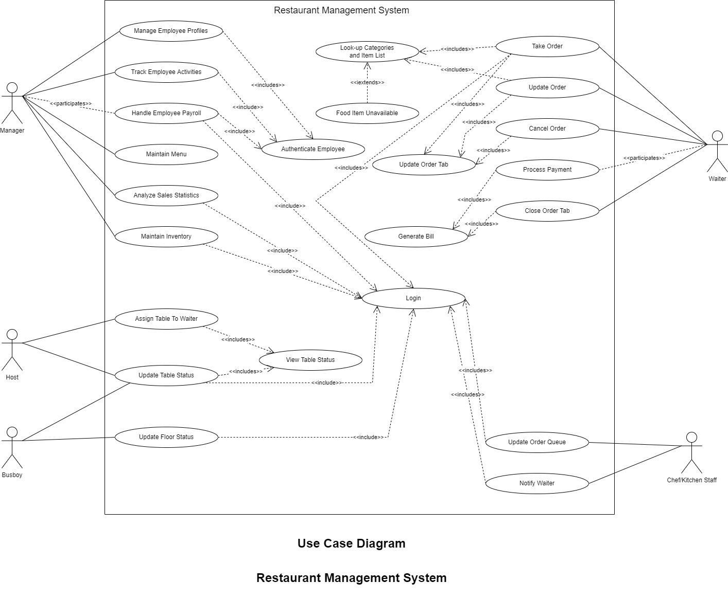

*Use case Diagram v1.1*

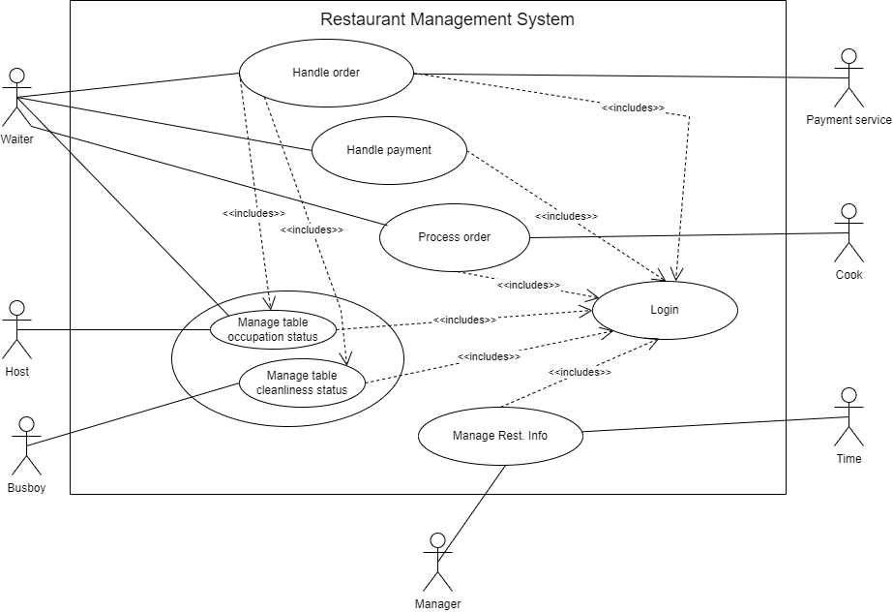

### **UCD Prioritization**

| **Fully dressed** | **Casual** | **Brief** |
| --- | --- | --- |
| Handle order | Process order | Handle payment |
|  |  | Manage table status |
|  |  | Manage cleanliness status |
|  |  | Login |

## ***Use Case Descriptions***

### **UC 1 *(add name here)***

### **UC1 Description**

*(in fully dressed format. Use template discussed in class here)*

#### **UC 1 «Includes»**

*(in fully dressed format. Use include template for each include)*

#### **UC 1 «Extends»**

*(the most important <<extends>> in fully dressed format. Use extend template for each extension. List other extensions in brief format)*

#### **UC 1 Non-Functional Requirements**

*(list the product, process and external NFRs)*

### **UC 2 *(add name here)***

### **UC 2 Description**

(*define UC2 in a casual format- Use text here*)

#### **UC 2 «Includes»**

*(list the <<includes>>, if there are any)*

#### **UC 2 «Extends»**

*(list the extensions, if identified in the description)*

#### **UC 2 Non-Functional Requirements**

*(list the product, process and external NFRs, if mentioned in the description)*

### **UC 3 *(add name here)***

### **2.3.1 UC 3 Description**

(*define UC2 in a brief format- Use text here*)

#### **2.3.2 UC 3 «Includes»**

*(list the <<includes>>, if there are any)*

#### **2.3.3 UC 3 «Extends»**

*(list the extensions, if identified in the description)*

#### **2.3.4 UC 3 Non-Functional Requirements**

*(list the product, process and external NFRs, if mentioned in the description)*

## ***Etc.***

# **III. System Sequence Diagrams**

Version X.X

Date

## ***Revision History***

| **Version - description** | **Date** | **Description** | **Author** |
| --- | --- | --- | --- |
|  | … |  | … |
|  | … |  | … |
|  | … |  | … |
|  |  |  |  |

## ***1. UC1 System Sequence Diagram***

*(Add UC1 SSD here)*